HOW I CREATED MY FIRST RESTFUL API FOR VAADHYA

Sabse pehle socha aur fir experienced Thapa bhai ke videos se file structure kaisa hoga woh seekha. So let’s discuss about it…

Sabse pehle main folder hoga which in our case is – Spotify.

Usme saare npm packages install kiye hai. Then src folder banaya jisme saari backend related files hogi. So first I created index.js file jisme saari files merge hogi. So sabse pehle toh usme maine server create kiya using express.

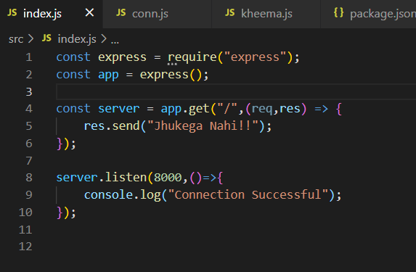

In short, woh apni main file hai. Then in src folder only, I created 2 new folders.

1. Models
2. db

In models, we will store schema related files. In db we will store connection related files. So I made a file – conn.js in db folder. In conn.js, I made it to connect it with mongodb.

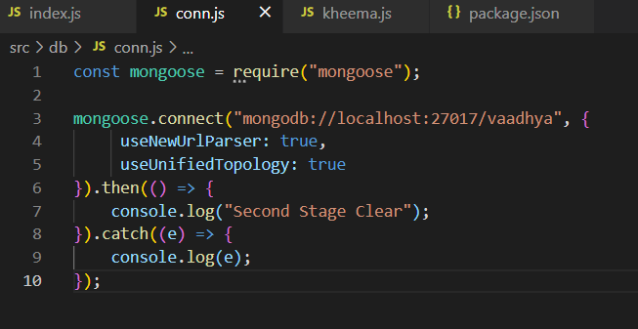Then I merged/connected conn.js and index.js by just requiring conn.js

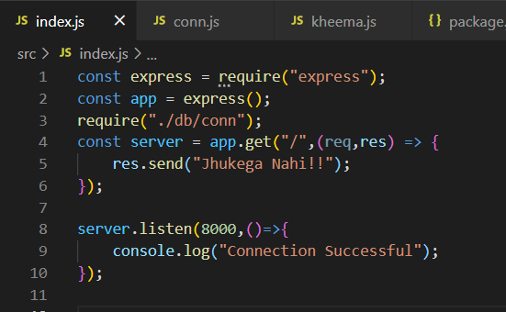

Then I started with Schema i.e. kheema.js. I required mongoose and validator for defining schema. Then I defined structure of schema. Then made a collection of that schema and then finally exported that collection to use in our main file i.e. index.js.

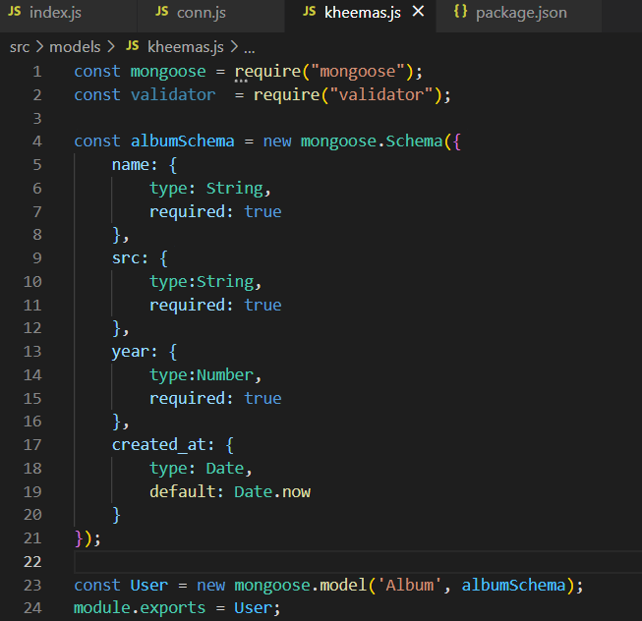Then imported this schema in our main file.



Then created post, to take data from postman. But don’t forget to add express.json() middleware in your file.

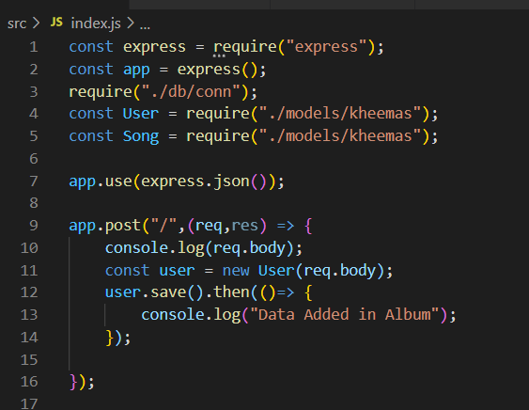

Now its all done. Just open postman and add data in json format from there and then it will go directly to your mongodb’s respective collection.

